16.68: a) The maximum velocity of the siren is 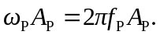 You hear a sound with frequency
b) The maximum (minimum) frequency is heard when the platform is passing through equilibrium and moving up (down).

